Parth Shukla
190905104
Lab 3

Exercise
1)
# Write a program to find the factors of a given number (get input from user) using for loop.

factors = []
n = int(input('Enter n'))

for i in range(1, n):
if(n%i == 0):
factors.append(i)

print('factors are')
for i in factors:
print(i)

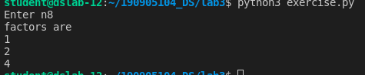

2)
# Find the sum of columns and rows using axis.
import numpy as np

a = np.array([[1, 2, 5],
[9, 6, 5],
[8, 4, 7],
[5, 7, 1]])

print(a.sum(axis=0))
print(a.sum(axis=1))

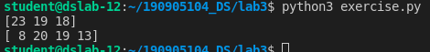

3)
#Operations on Arrays (use numpy wherever required):
# Create array from list with type float
# Create array from tuple
# Creating a 3X4 array with all zeros
# Create a sequence of integers from 0 to 20 with steps of 5
# Reshape 3X4 array to 2X2X3 array
# Find maximum and minimum element of array, Row wise max and min, column wise max and min and sum of elements. (Use functions max(), min(), sum())

import numpy as np

li = [3.5, 6.7, 8.45, 9.0, 3.2]

a = np.array(li)
print(a.dtype)
tu = (3.5, 6.7, 8.45, 9.0, 3.2, 6.9)
b = np.asarray(tu)
print(b)

z = np.zeros((3, 4))
print(z)

seq = np.arange(0, 20, 5)
print('shape before', z.shape)
z = z.reshape((2, 2, 3))
print('shape after', z.shape)

b = b.reshape((3, 2))

print(b)
print('columnwise max', b.max(axis = 0))
print('rowwise max', b.max(axis = 1))

print('columnwise min', b.min(axis = 0))
print('rowwise min', b.min(axis = 1))

print('columnwise sum', b.sum(axis = 0))
print('rowwise sum', b.sum(axis = 1))

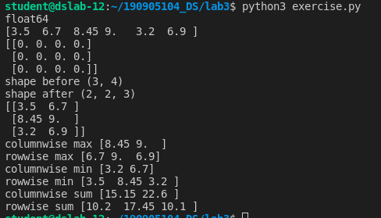

4)
# Write a program to transpose a given matrix.
import numpy as np

tu = (3.5, 6.7, 8.45, 9.0, 3.2, 6.9)
b = np.asarray(tu)
b = b.reshape((2, 3))
print(b)
print('transpose')
print(b.T)

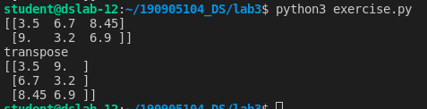

5)
# Write a program to add two matrices

import numpy as np

a = np.linspace(0,30,15).reshape((3, 5))
b = np.linspace(0,20,15).reshape((3, 5))
print('a=', a)
print('b=', b)
print('sum=', a+b)

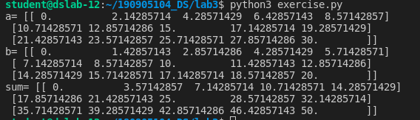

6)
# Write a program to find element wise product between two matrices.
import numpy as np
a = np.linspace(0,30,15).reshape((3, 5))
b = np.linspace(0,20,15).reshape((3, 5))
print('a=', a)
print('b=', b)

print('Element wise multiplication= ', np.multiply(a, b))

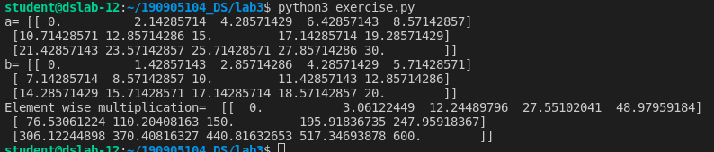

Practice

Array creation

a = np.array([2, 5, 10])
a.dtype

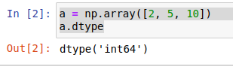

2-D array

A=np.array([(3,4,5),(12,6,1)])
Z=np.zeros((2,4))

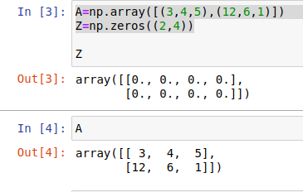

Numpy Arange
S=np.arange(10,30,5)
S

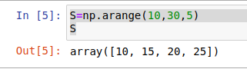

Numpy Arange with float argument
S = np.arange(0, 2, 0.4)
S

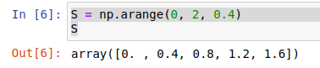
Specify number of elements in the array

S1=np.linspace(0,2,9)
S1

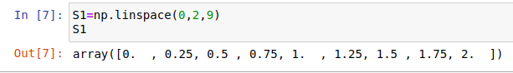

Random

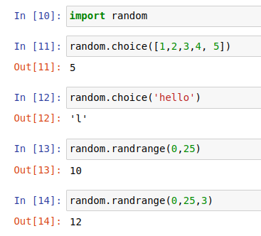

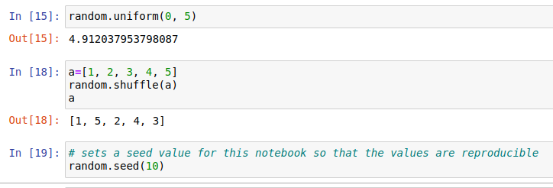

Reshape using numpy

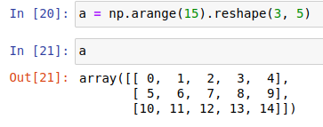

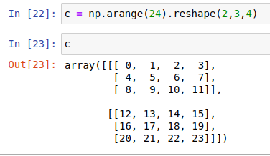

Slicing the array
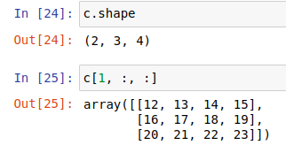

Array operations

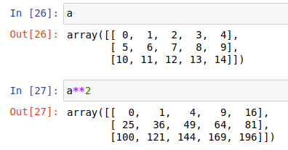

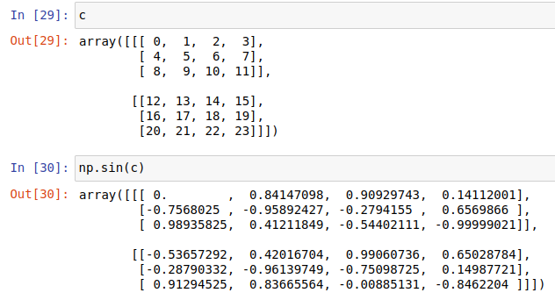
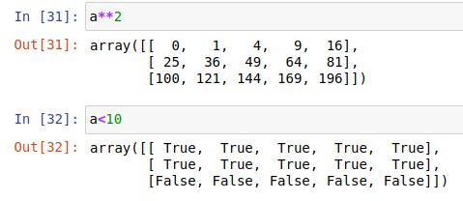

Matrix operations

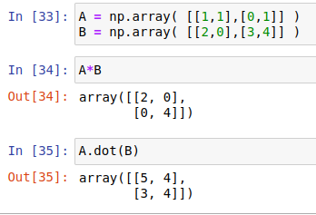

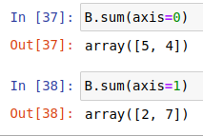

Indexing and slicing array

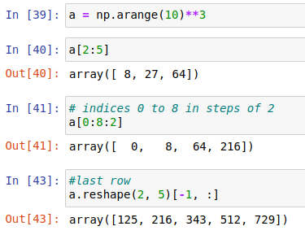

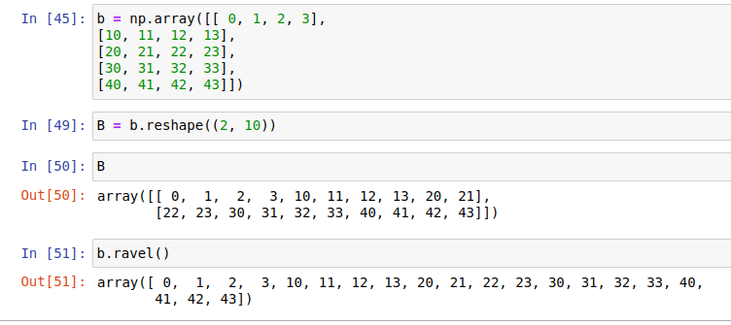

Stacking arrays on each other

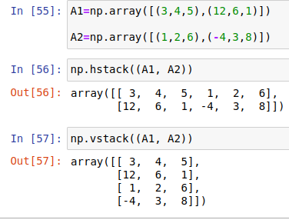

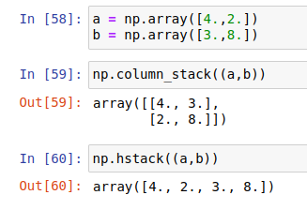

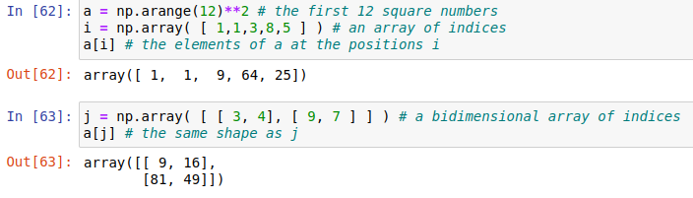

Mapping by value in for loops

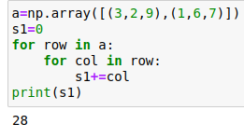

Mapping by index in for loops

